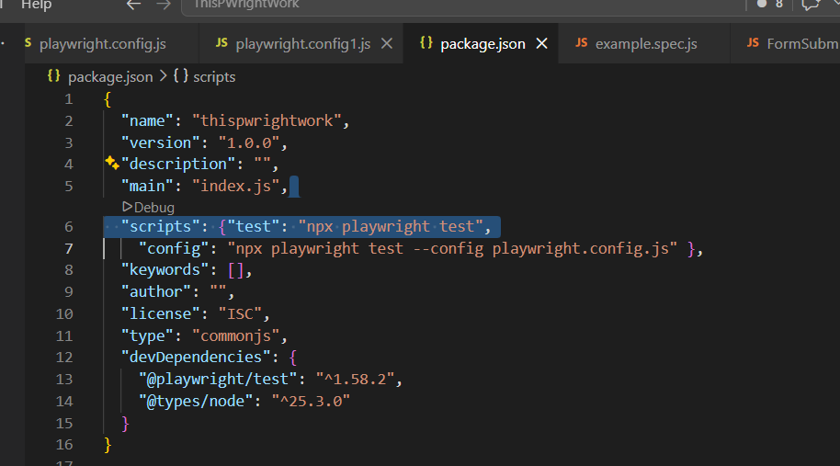
Config via running
n pm run test config DatePicker.js
npm run test
npx playwright test -g @Validation
npx playwright test --grep @Validation
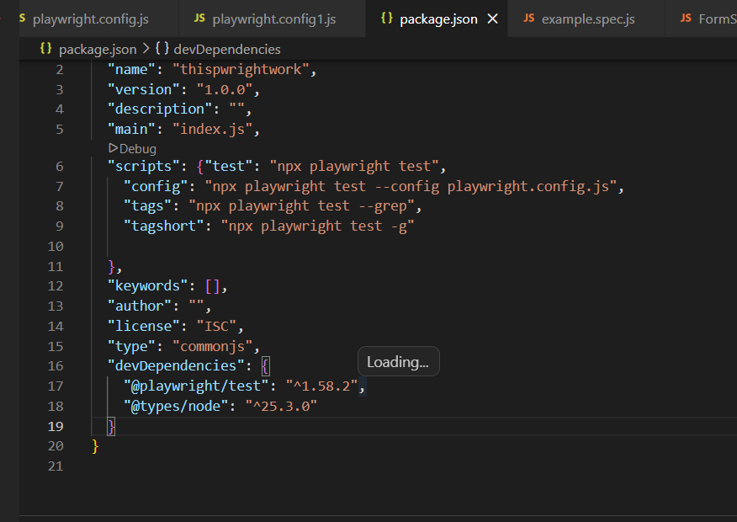
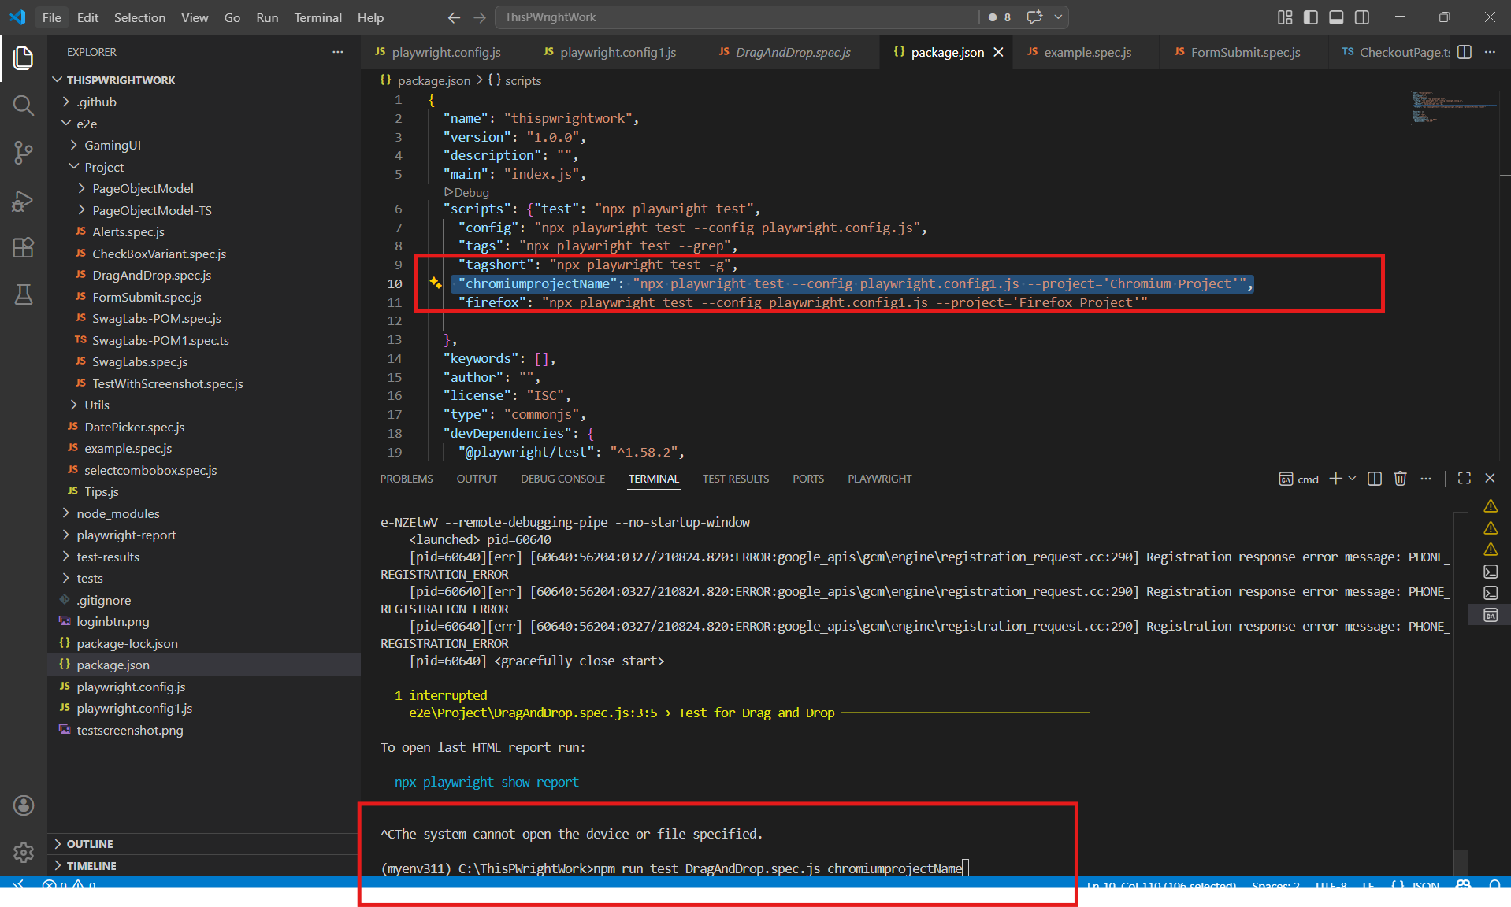

npm i -D @playwright/test allure-playwright
npx playwright test --reporter=line,allure-playwright

